Candidate_Result

Table as per design

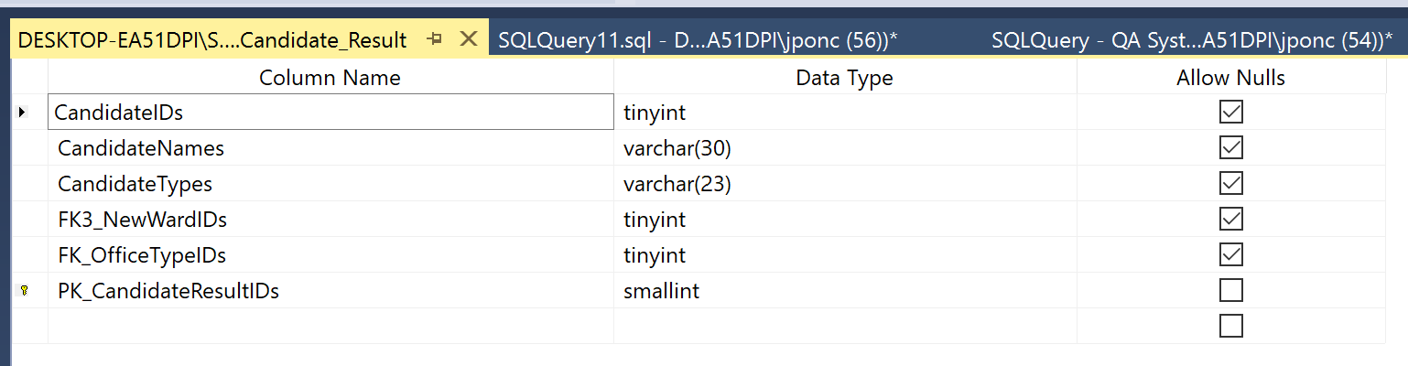

Rows retrieved 369 rows (131 distinct candidates, 14 distinct wards)

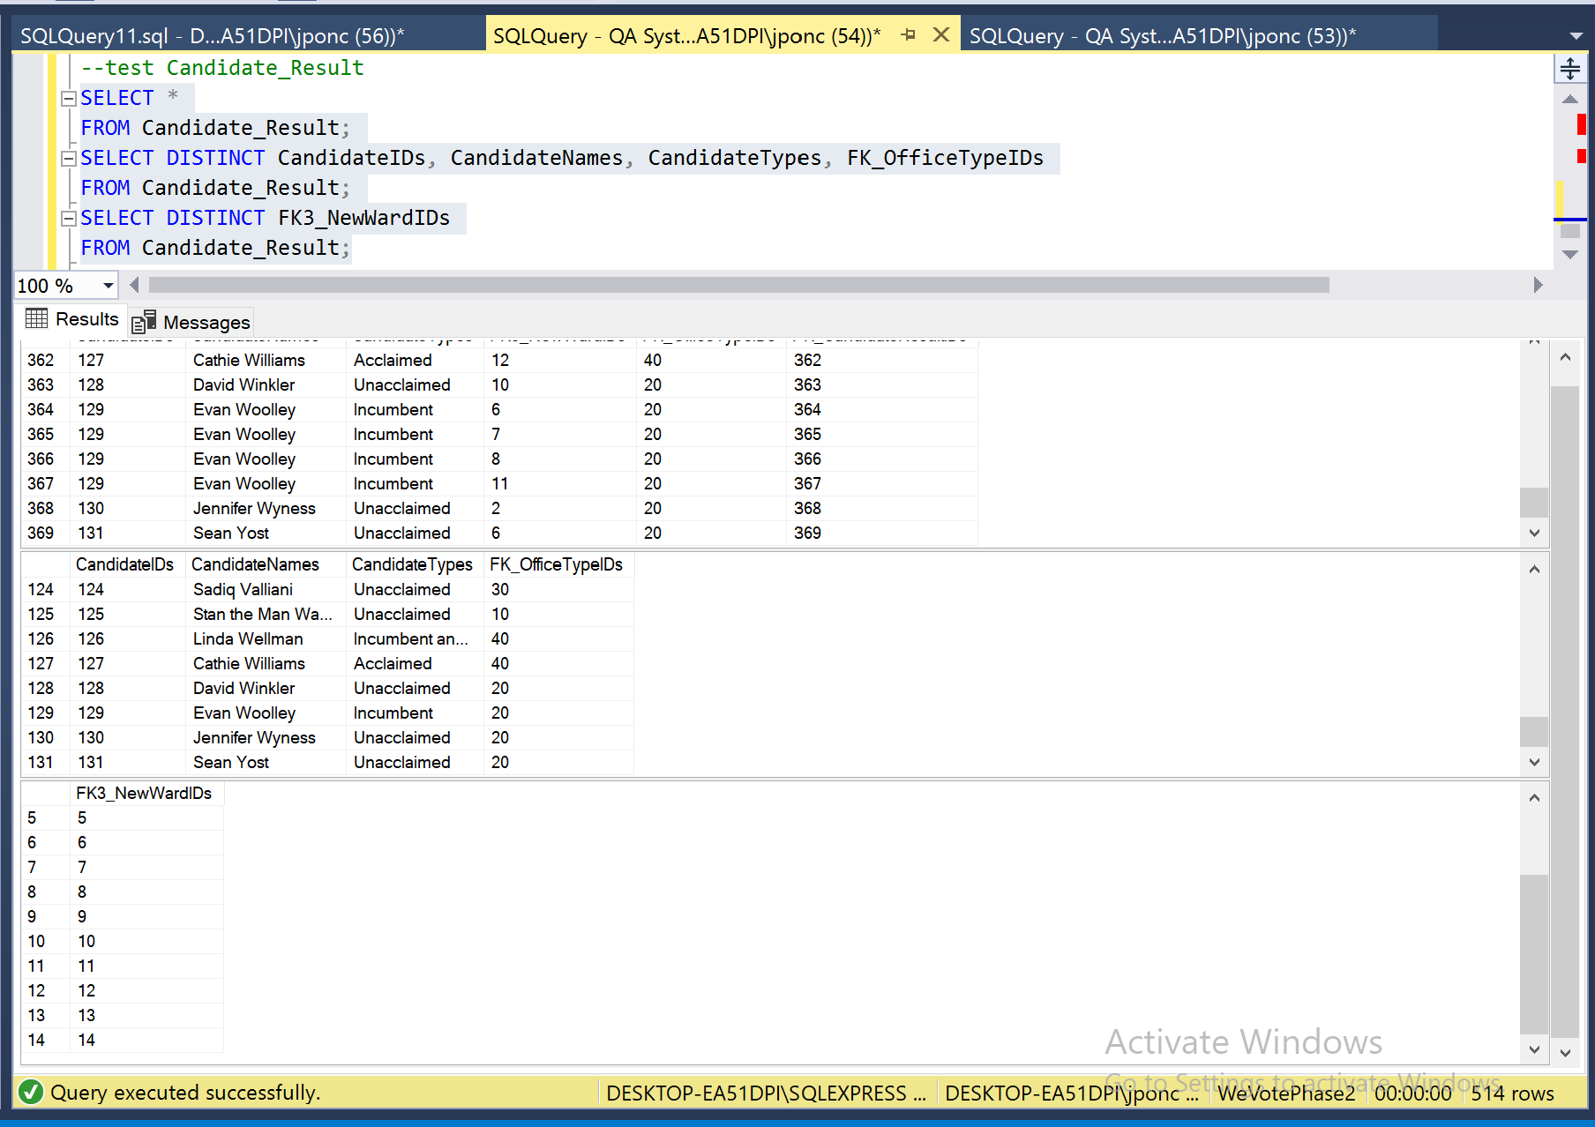

Data Manipulation

Primary Key - Explicit Insert for Identity Column

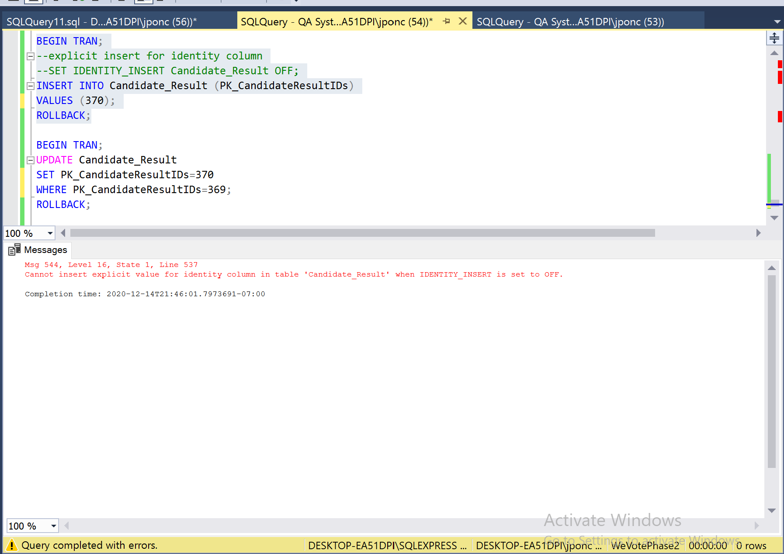

Primary Key – Update

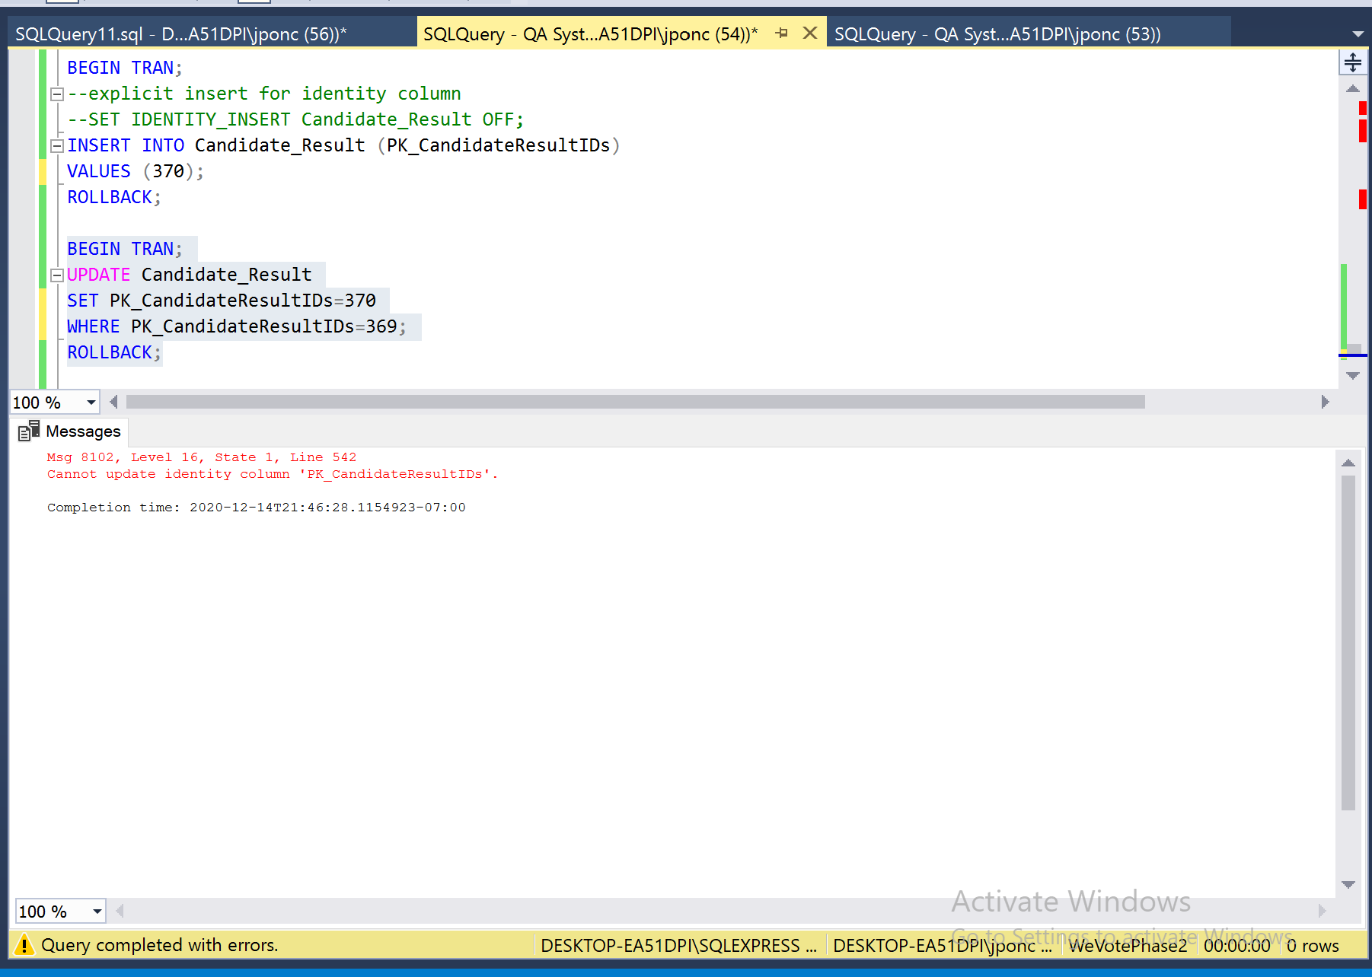

Primary Key related to other table and with Foreign Key

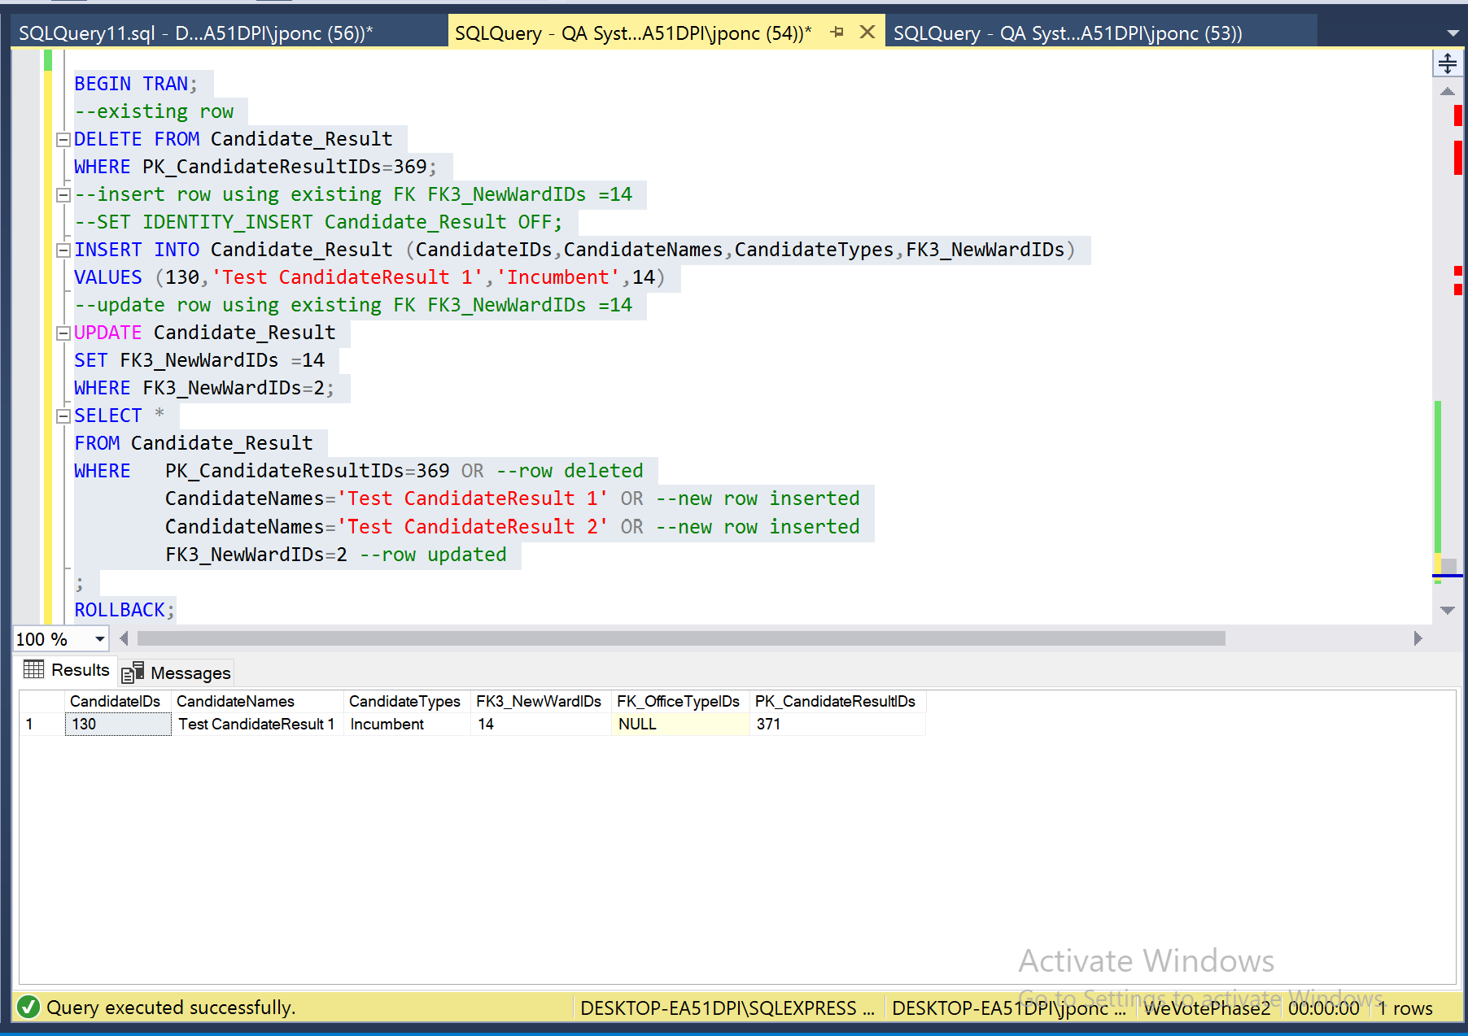

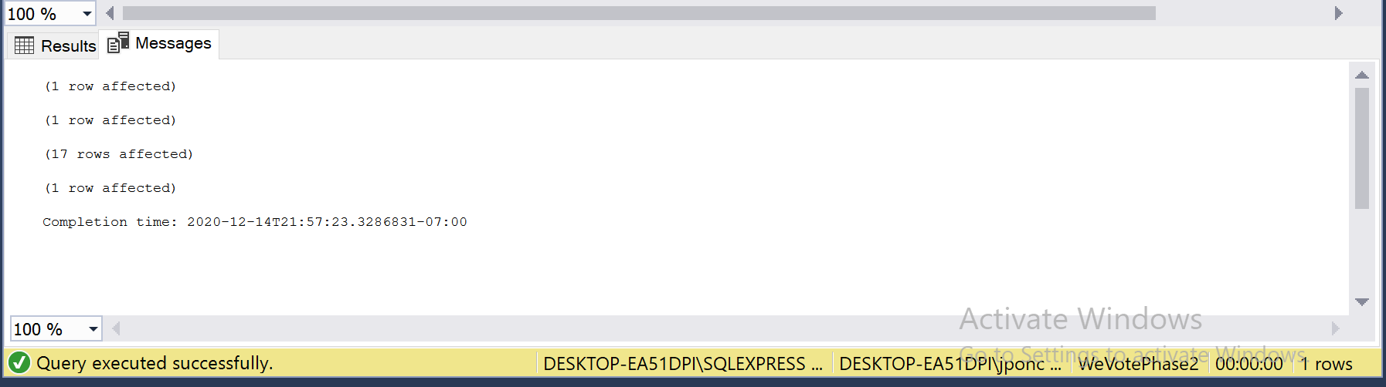

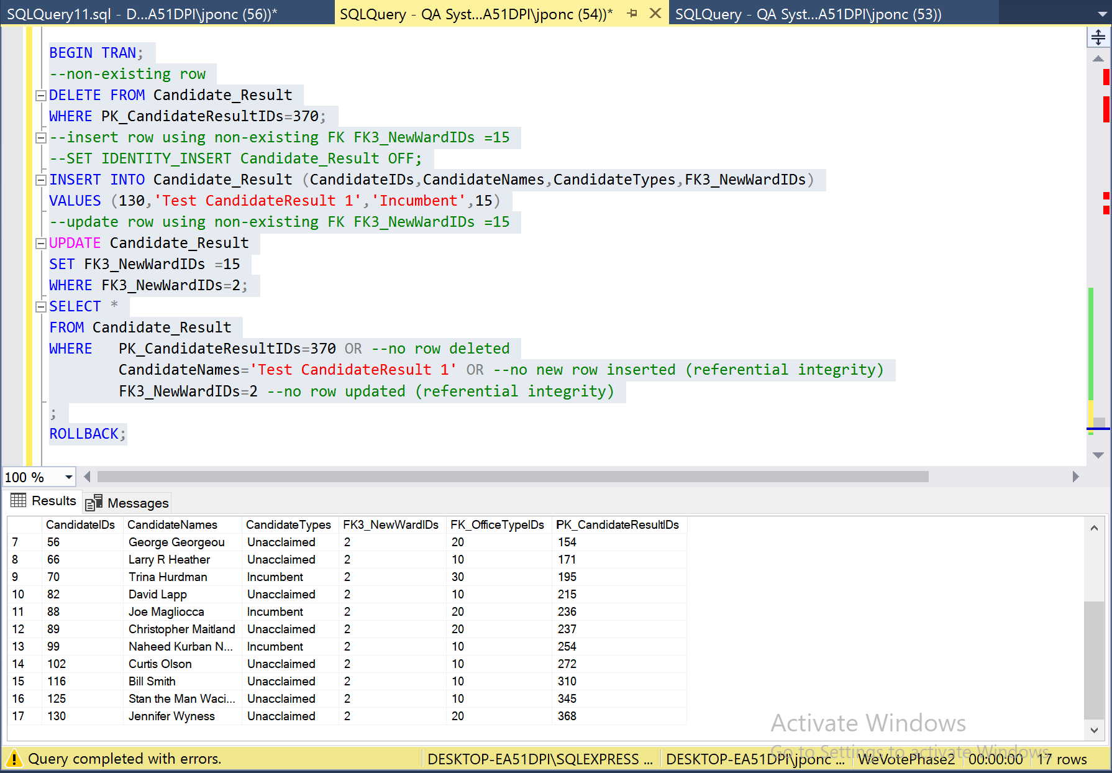

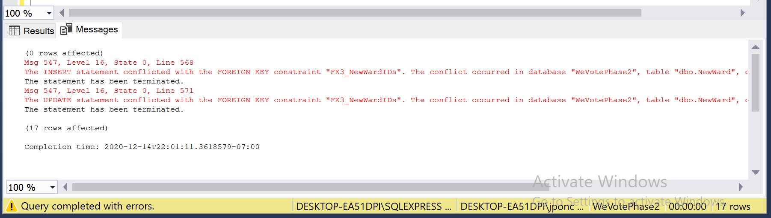

NOT NULL Constraint

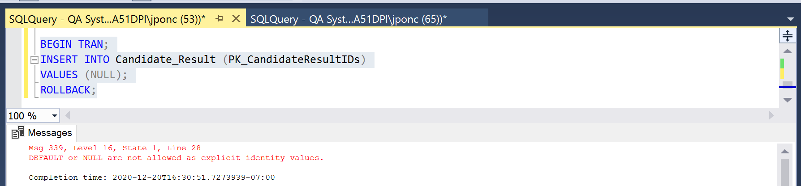

CHECK Constraint

